**Name : Mriganka Patra**

**Emp id: 2415820**

**Email : mriganka.patra@cognizant.com**

**Day 10**

**Assignment 1:**

Salesforce – Opportunities, Sales Path and Full Sales Cycle

Objective:

Learn to manage Opportunities, Configure Sales Path, and Demonstrate the Complete Sales Cycle within Salesforce.

Tasks:

1. Create a new Opportunity and Walk through the default stages: Prospecting to Closed Won / Lost
2. Add products to the Opportunity from a Pricebook:

* Include a least 2 different Products with quantities and discounts

1. Customize a Sales Path for Opportunities:

* Define key fields and guidance for each stage.

1. Simulate a full Sales Cycle:

* Convert a Lead – Create an Account & Contact – Create an Opportunity – Add Products – Close Opportunity

1. Use Activity Timeline to log a call , schedule a task, and send an email from the Opportunity record

Deliverables:

* Screenshots or Configuration of Opportunity stages and Sales Path
* Product details within the Opportunity
* Demonstration of complete sales cycle steps

Task 1:Create a new Opportunity and Walk through the default stages: Prospecting to Closed Won / Lost

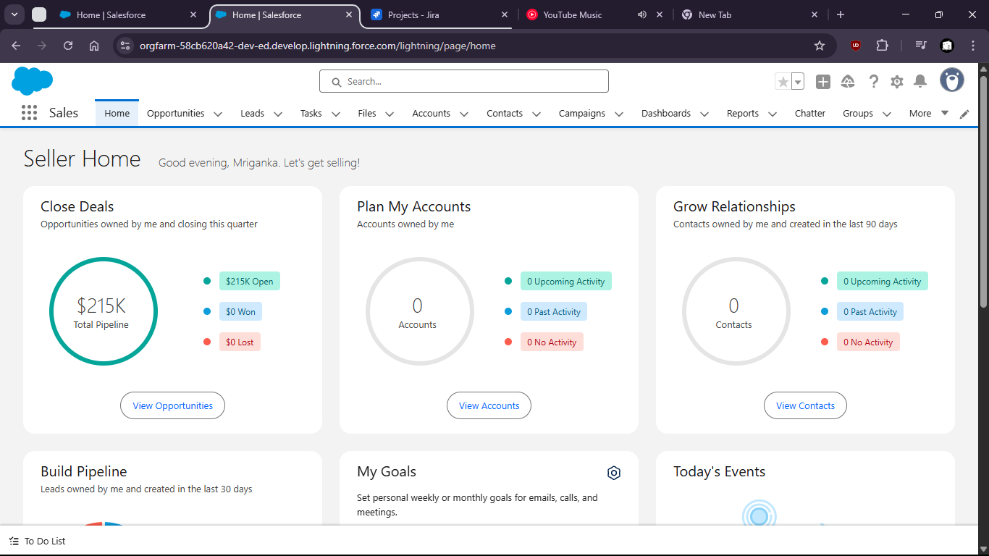

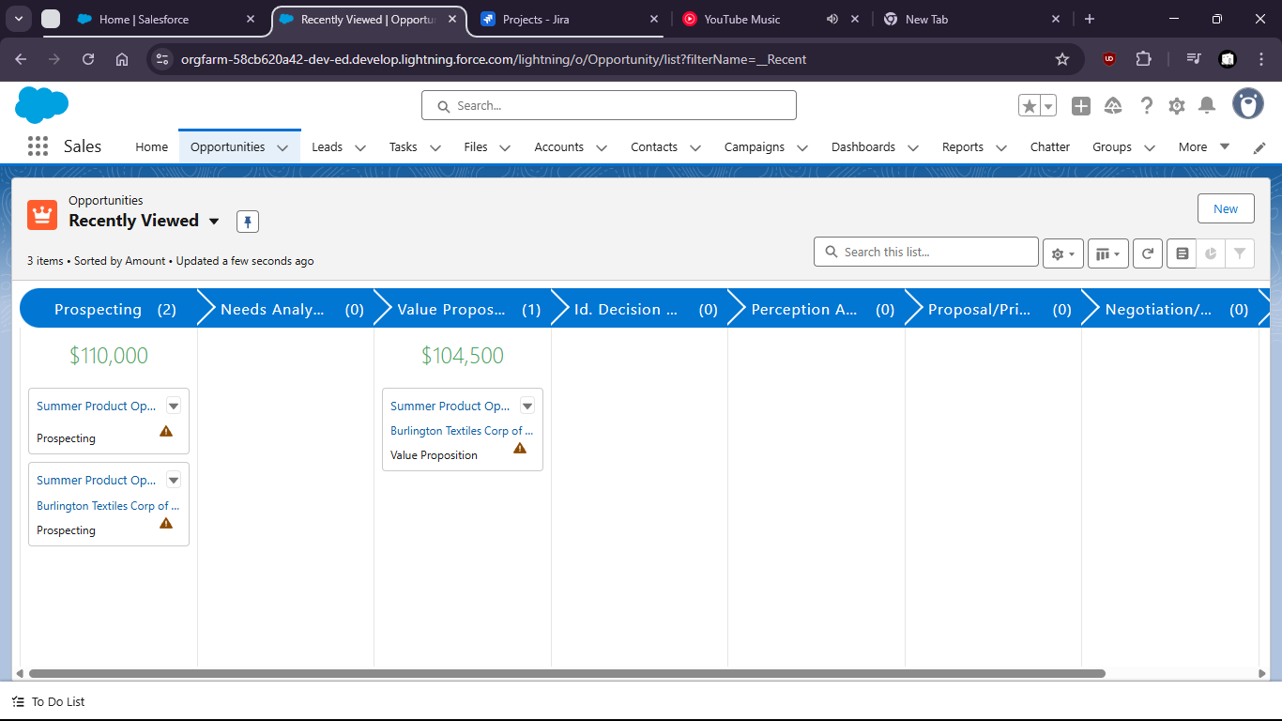

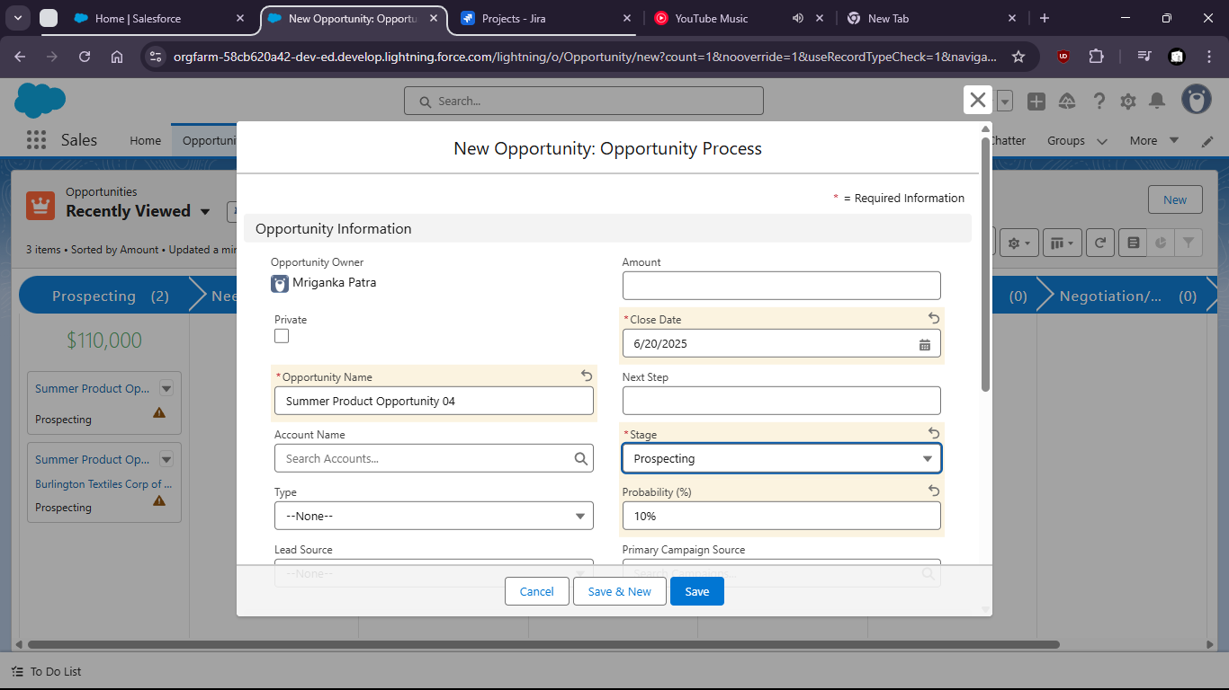

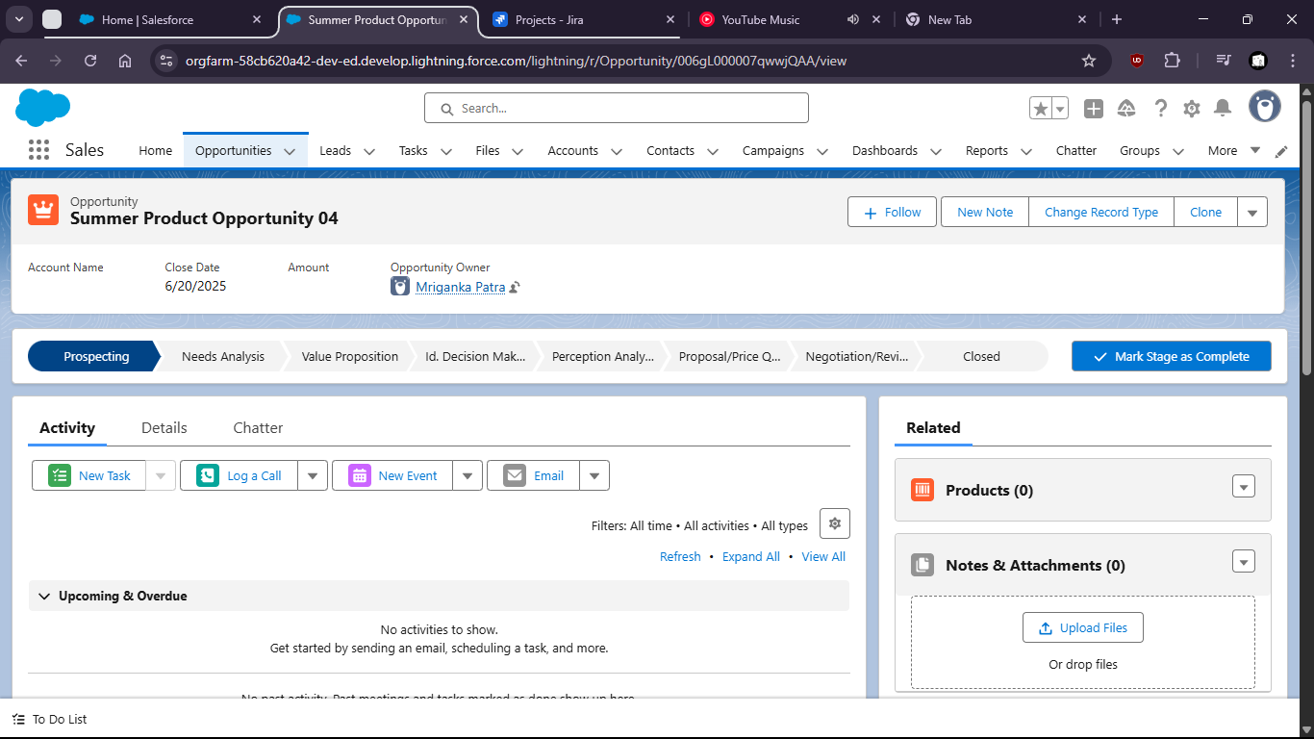

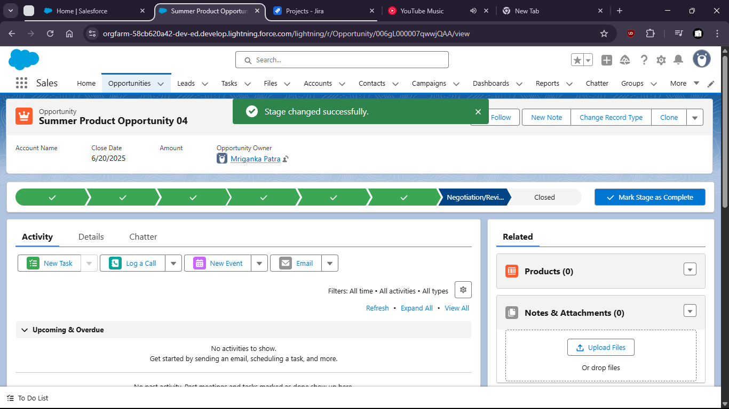

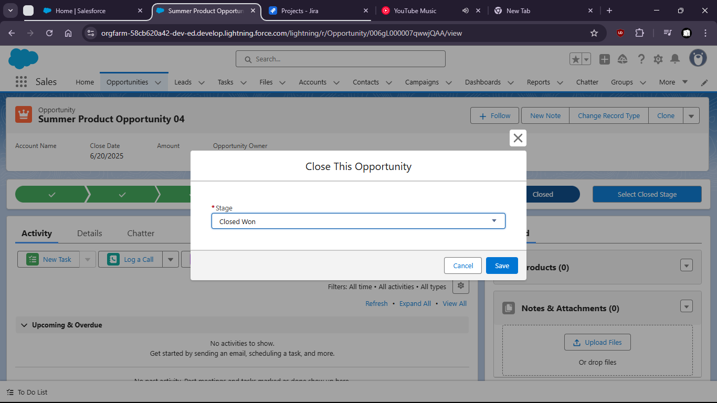

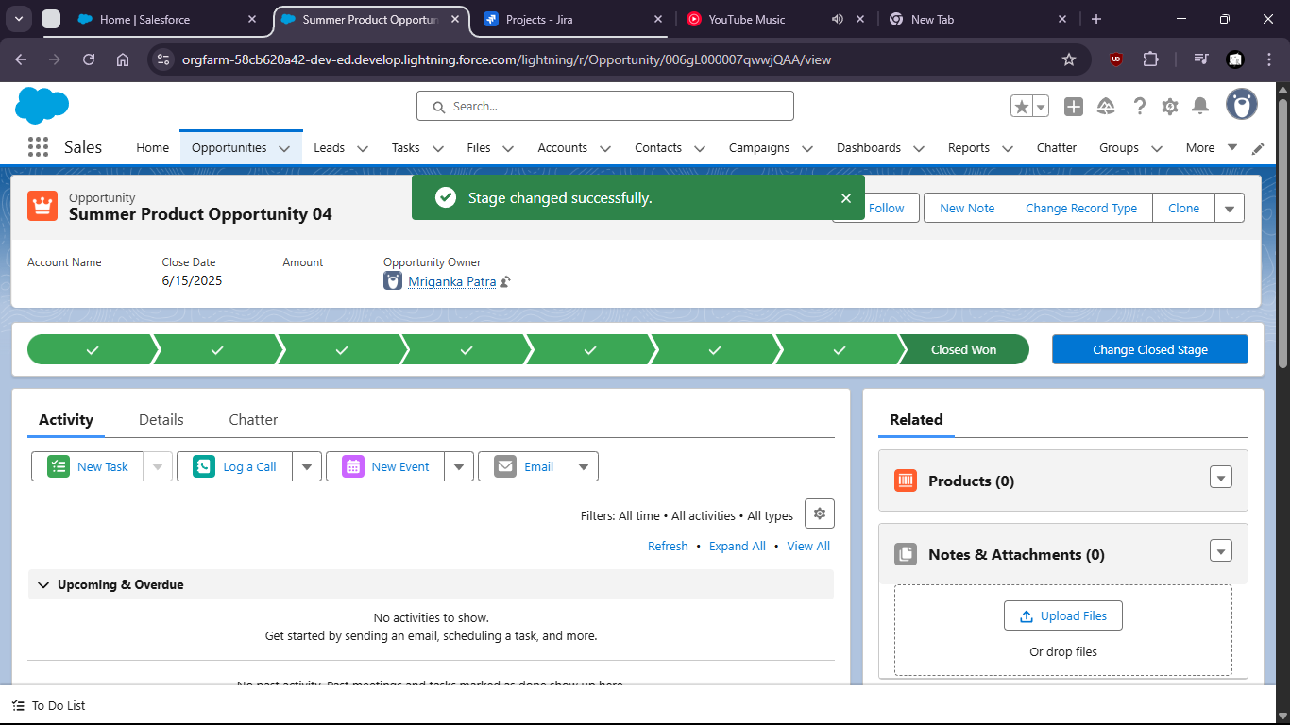

Task 2:Add products to the Opportunity from a Pricebook:

Include a least 2 different Products with quantities and discounts

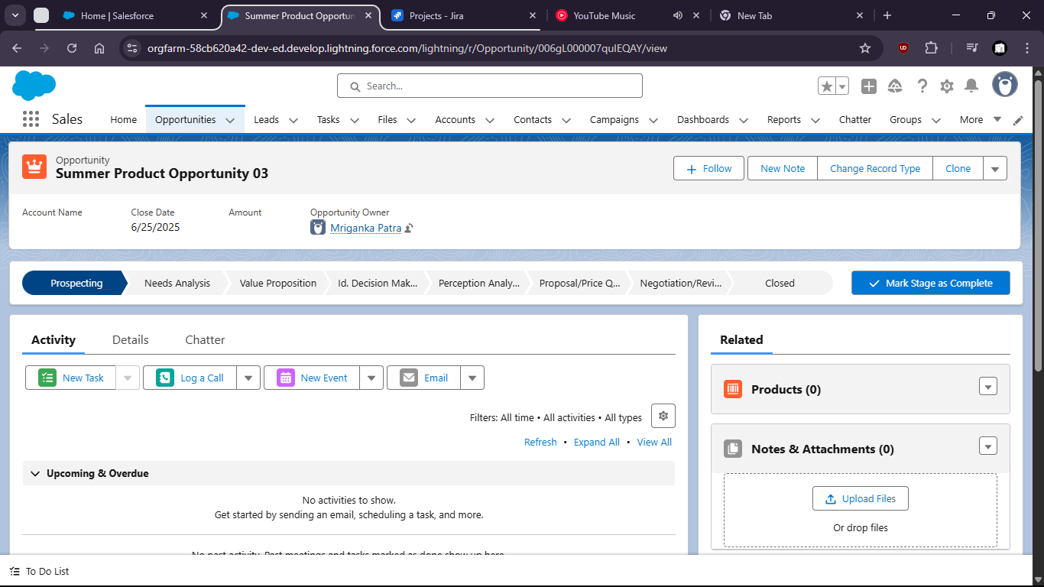

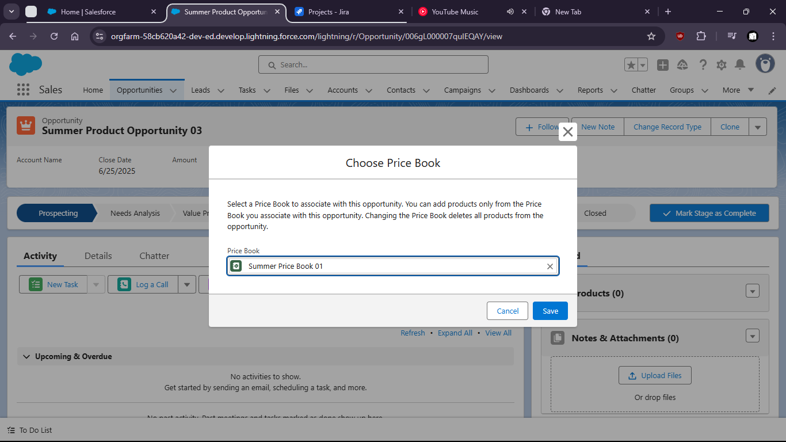

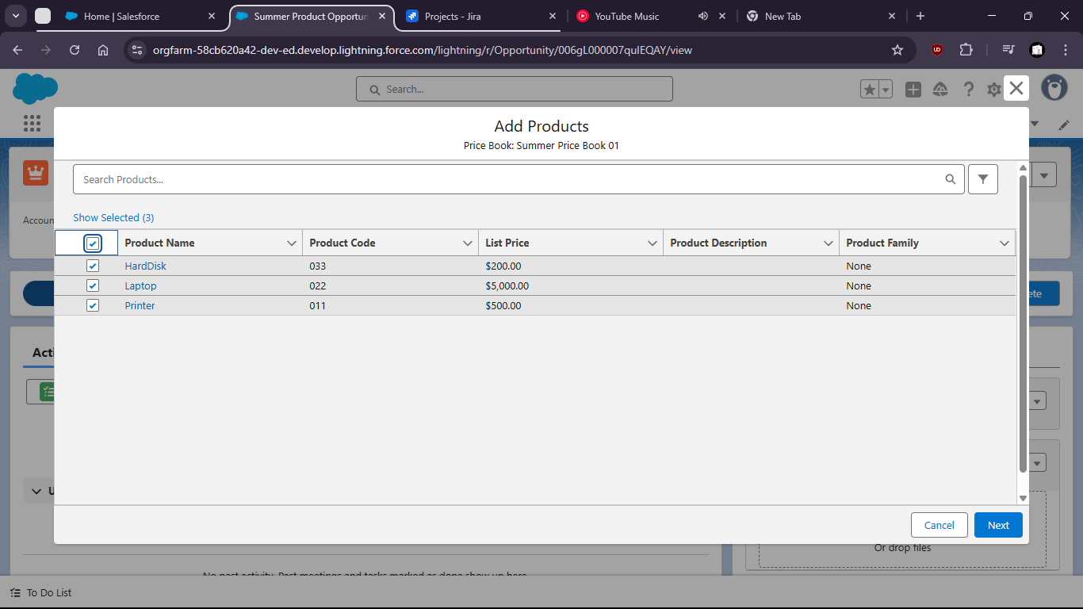

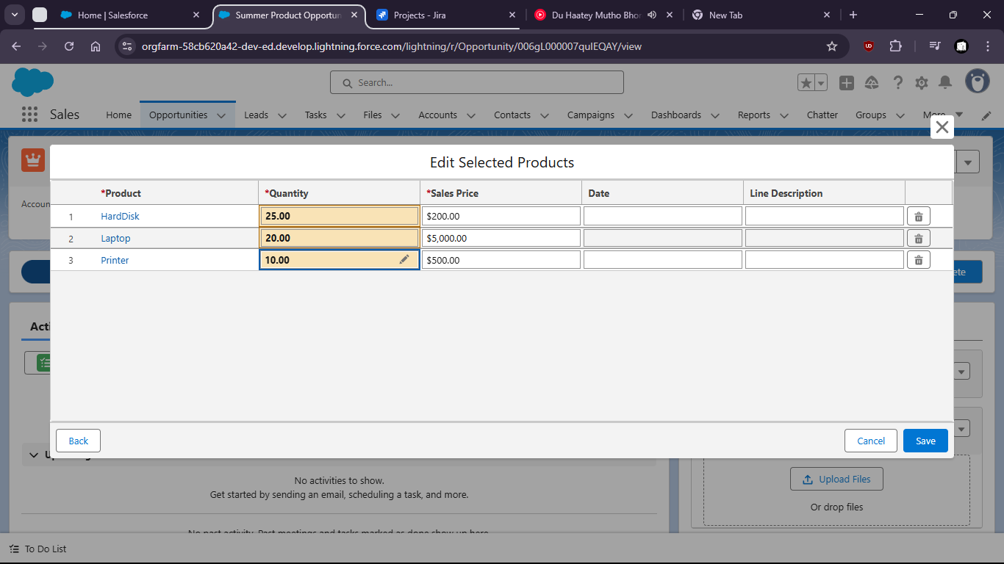

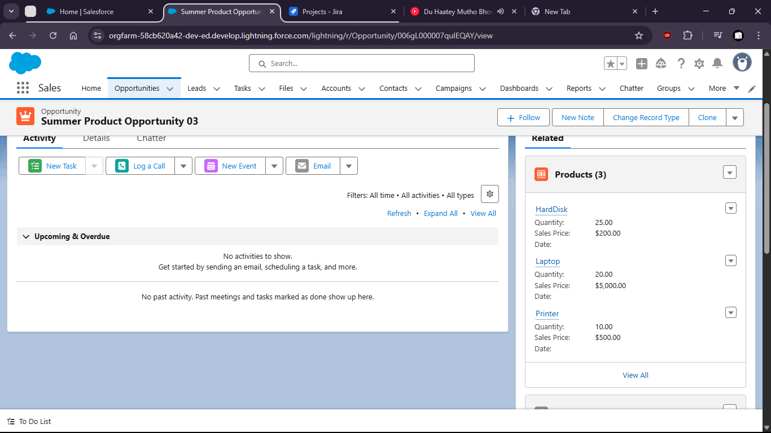

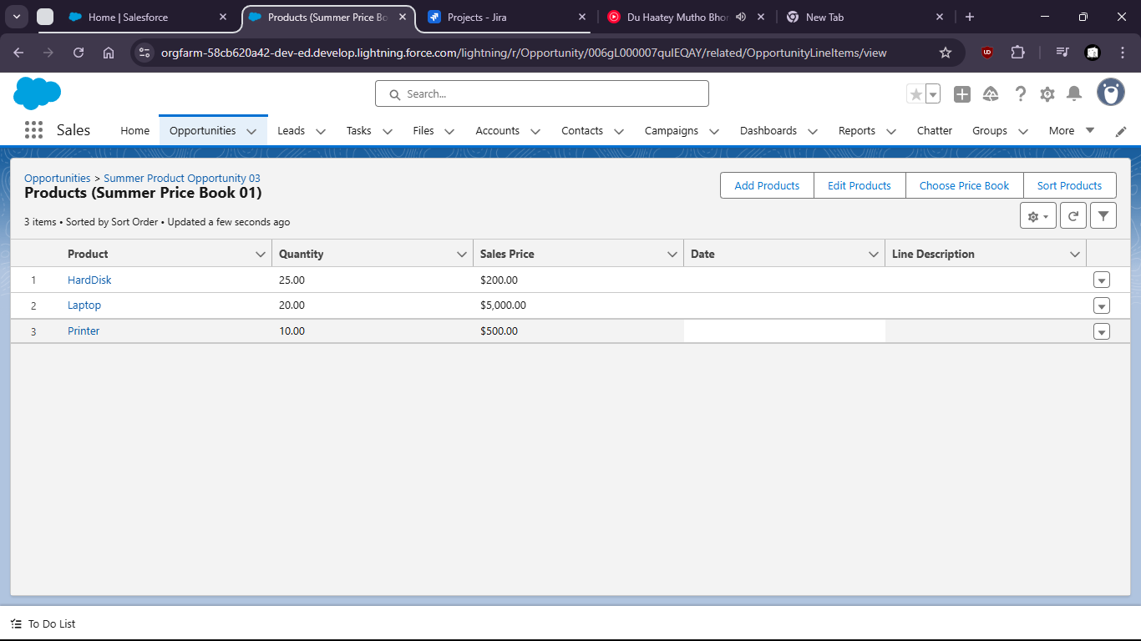

Task 3:Customize a Sales Path for Opportunities:

Define key fields and guidance for each stage.

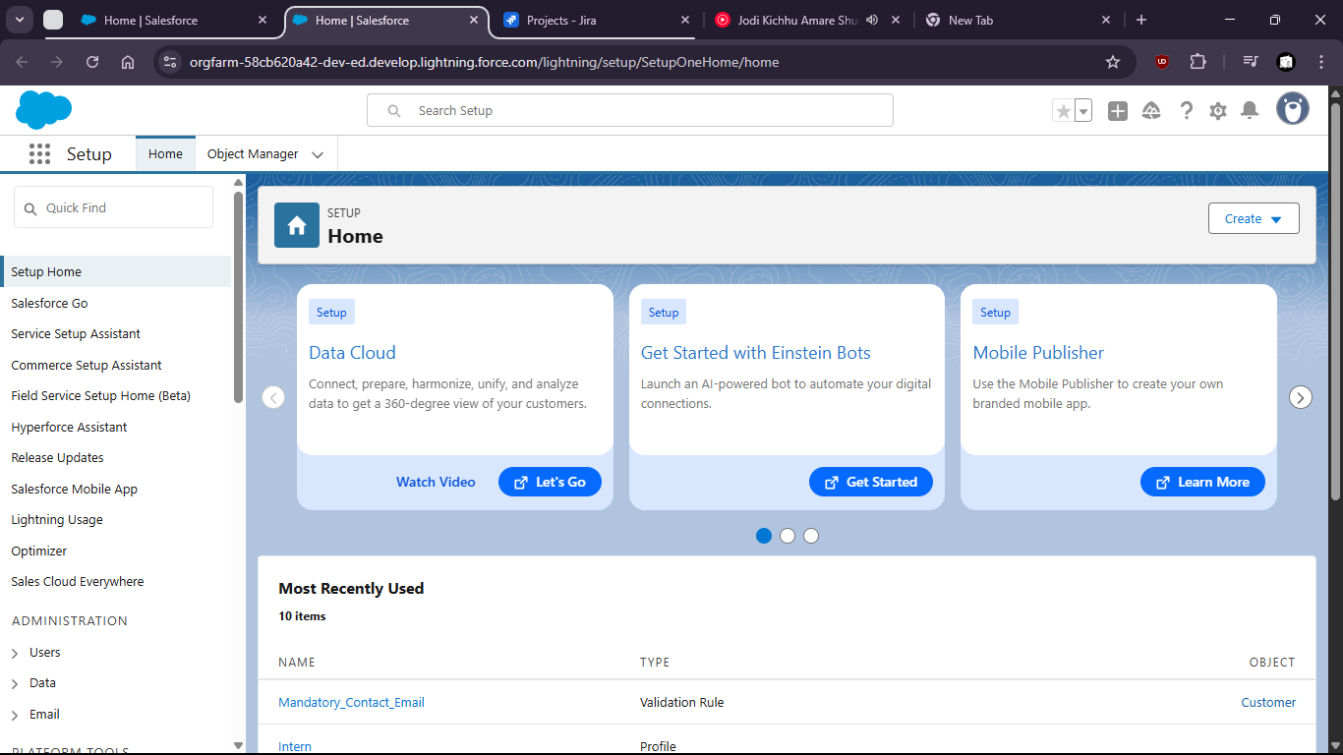

Goto setup > home > path settings.

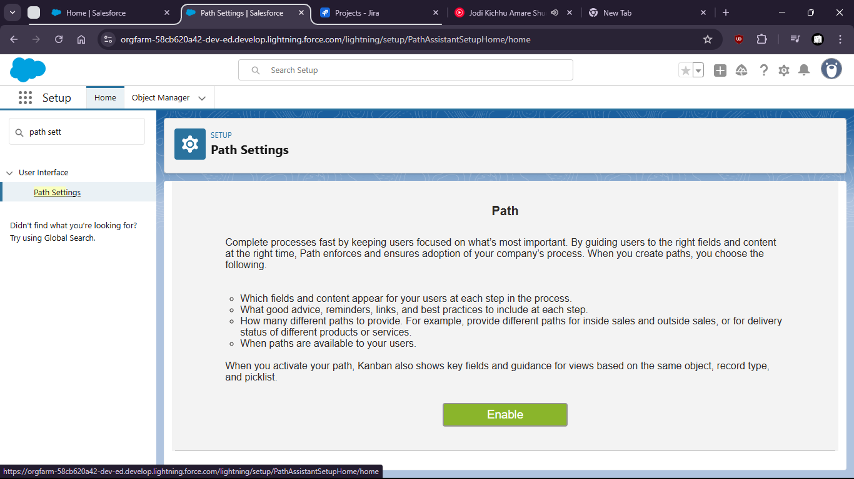

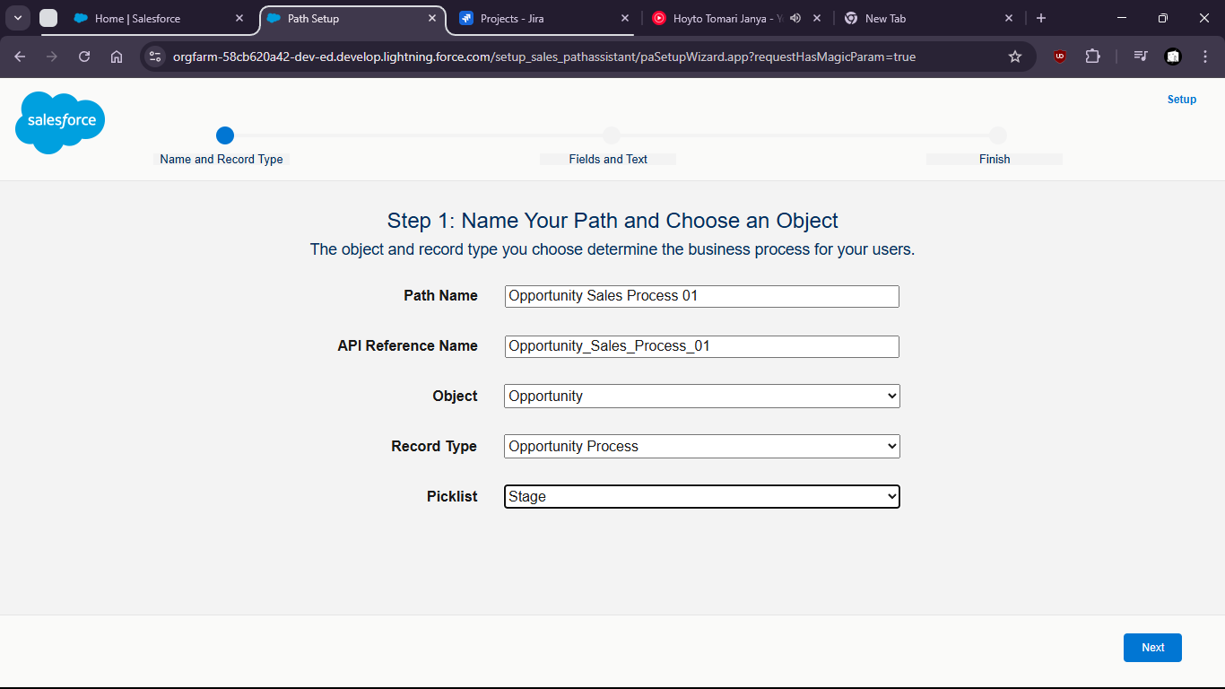

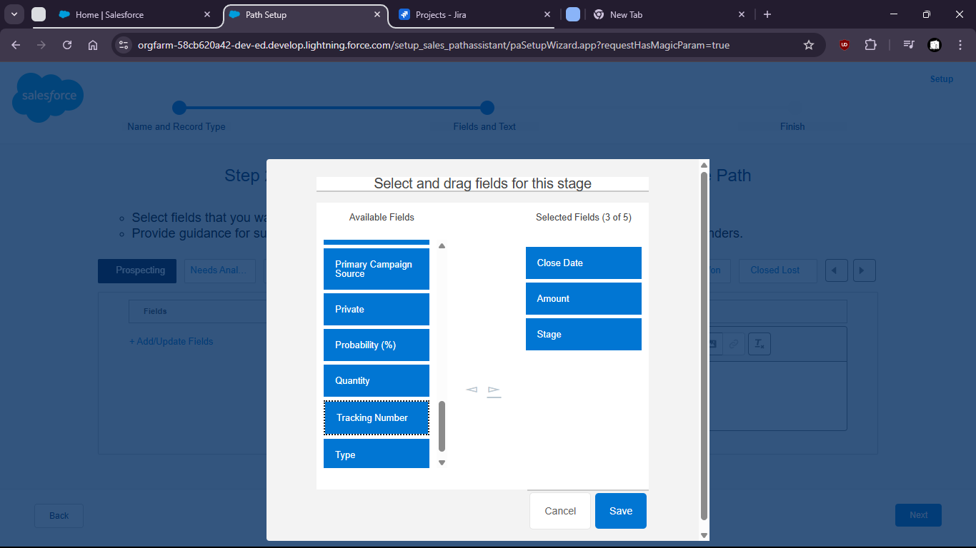

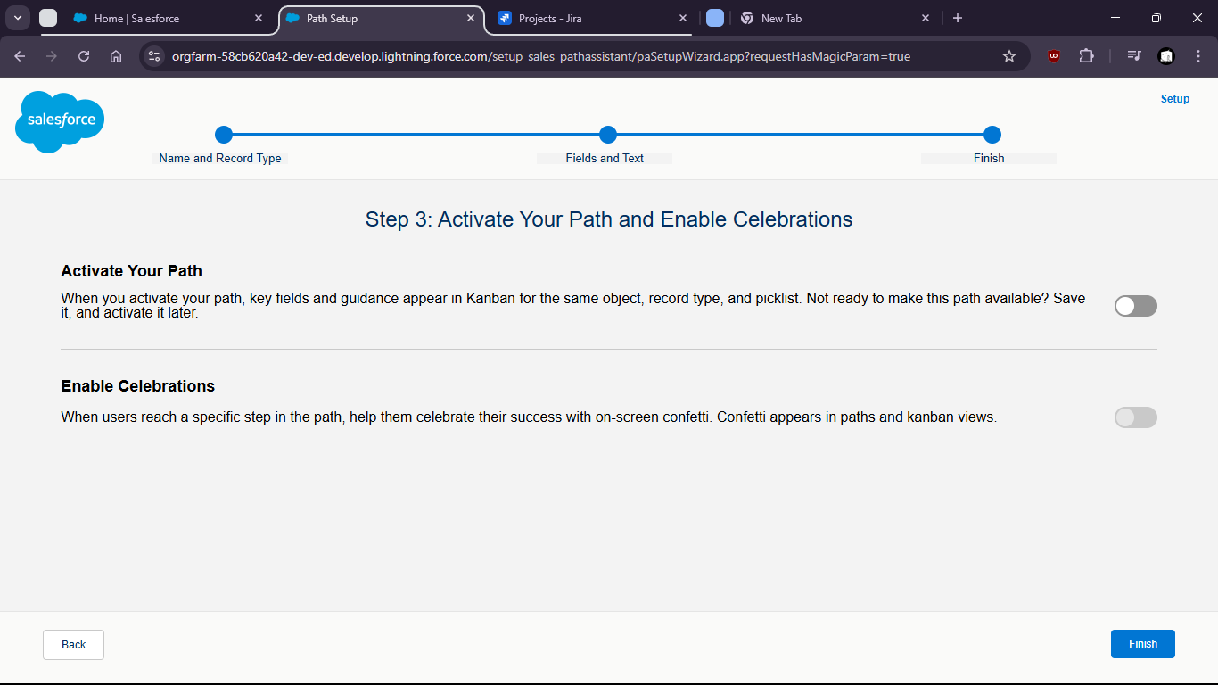

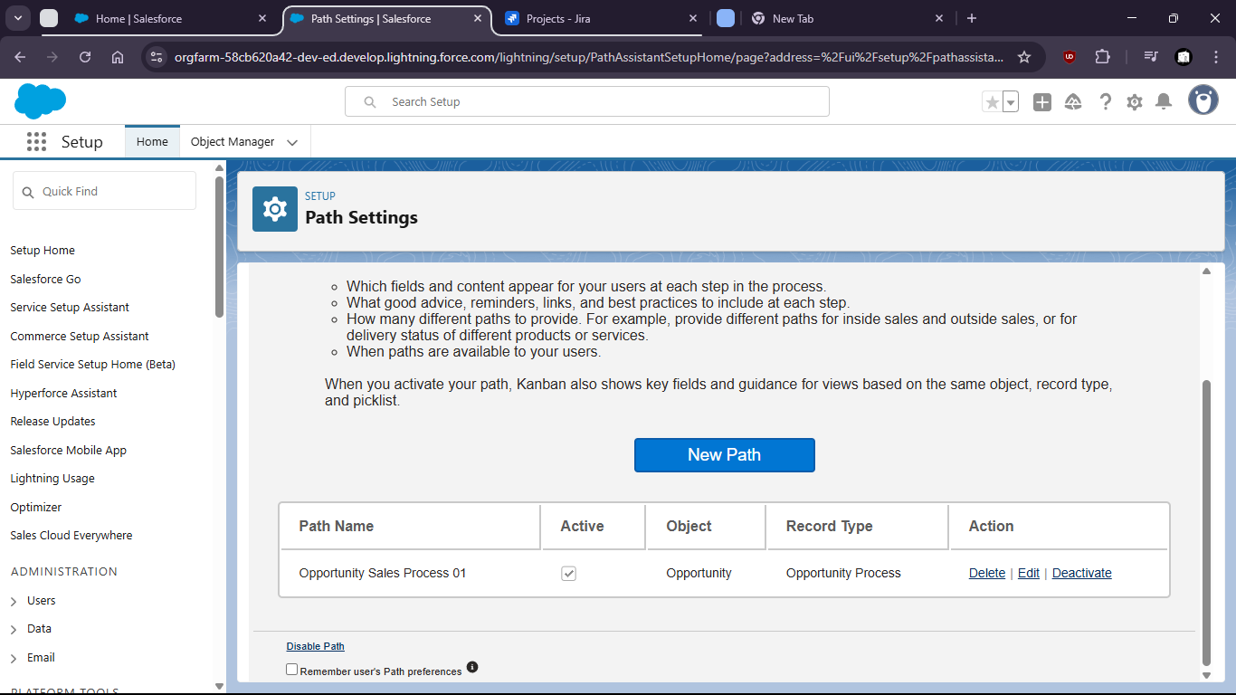

Task 4:Simulate a full Sales Cycle:

Convert a Lead – Create an Account & Contact – Create an Opportunity – Add Products – Close Opportunity

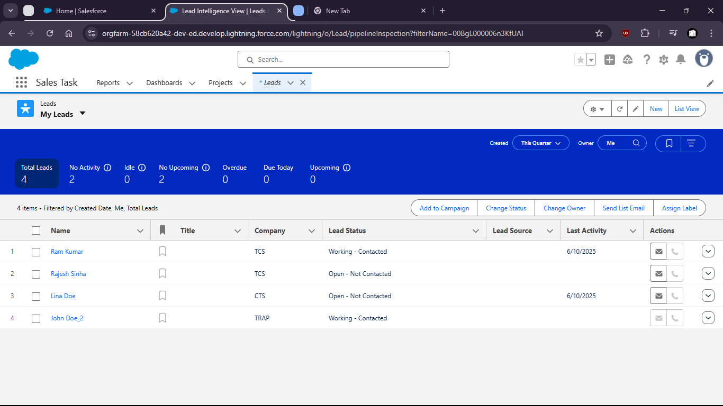

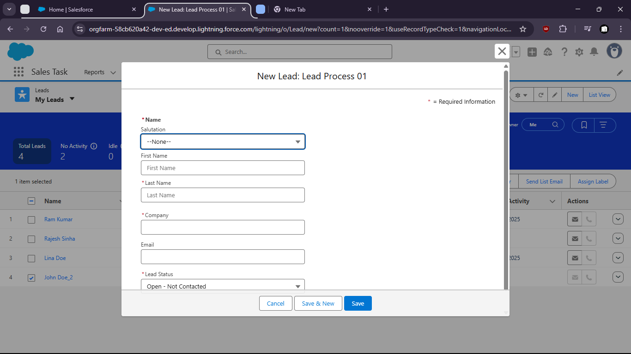

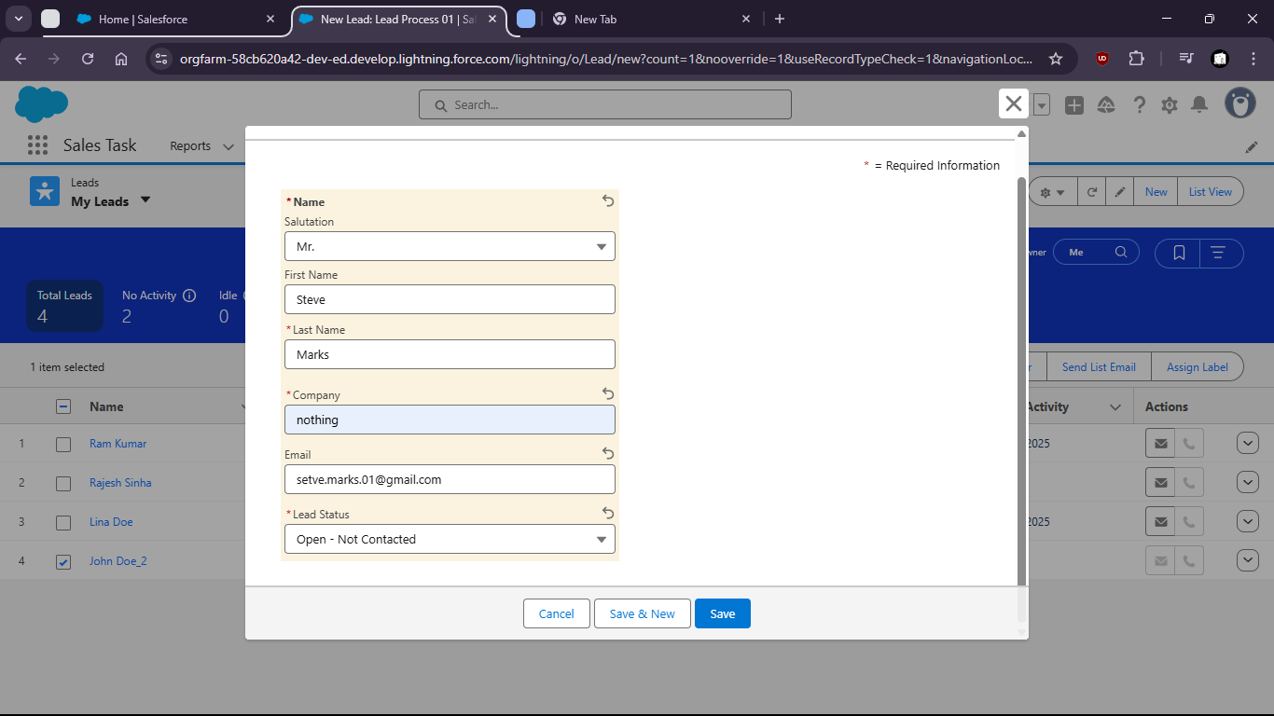

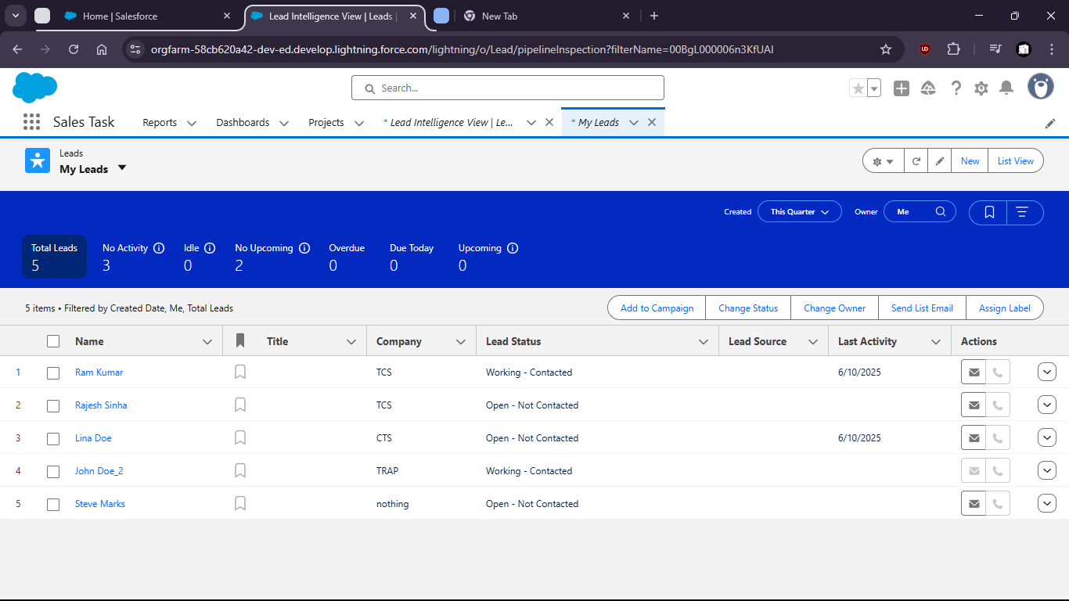

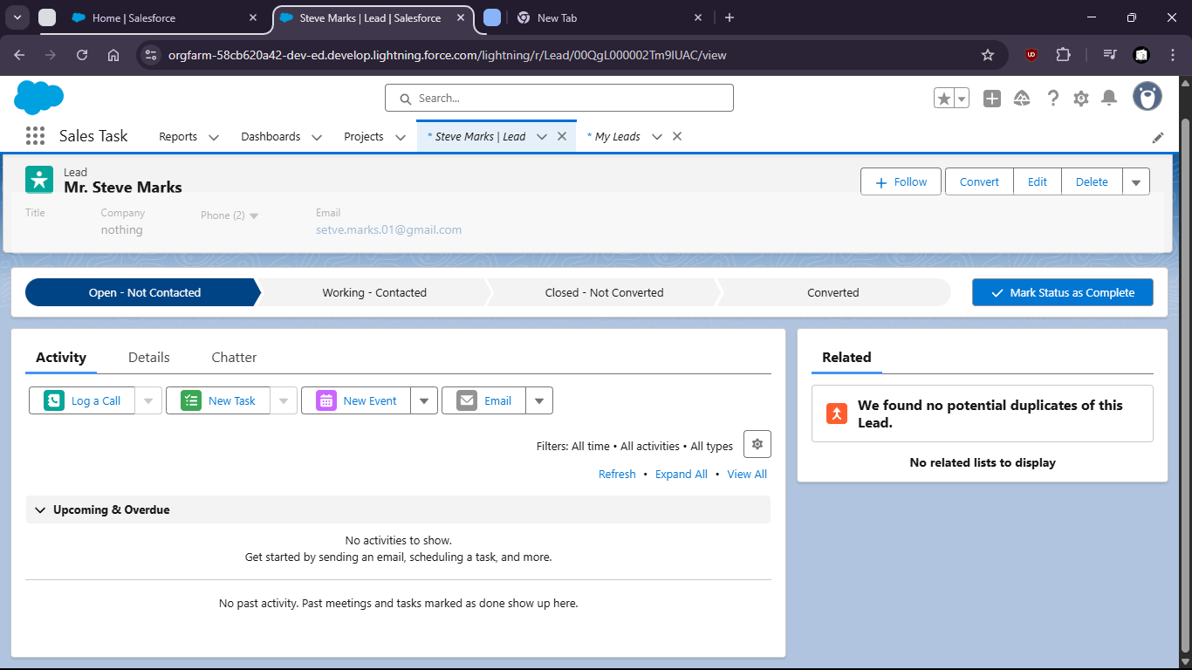

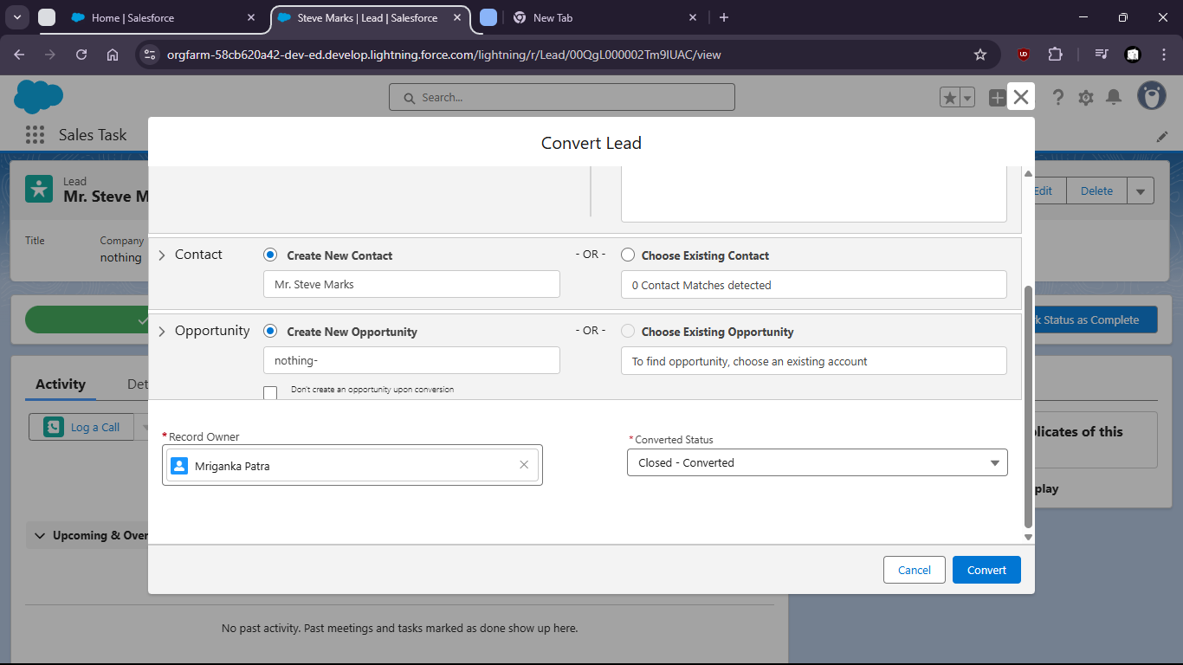

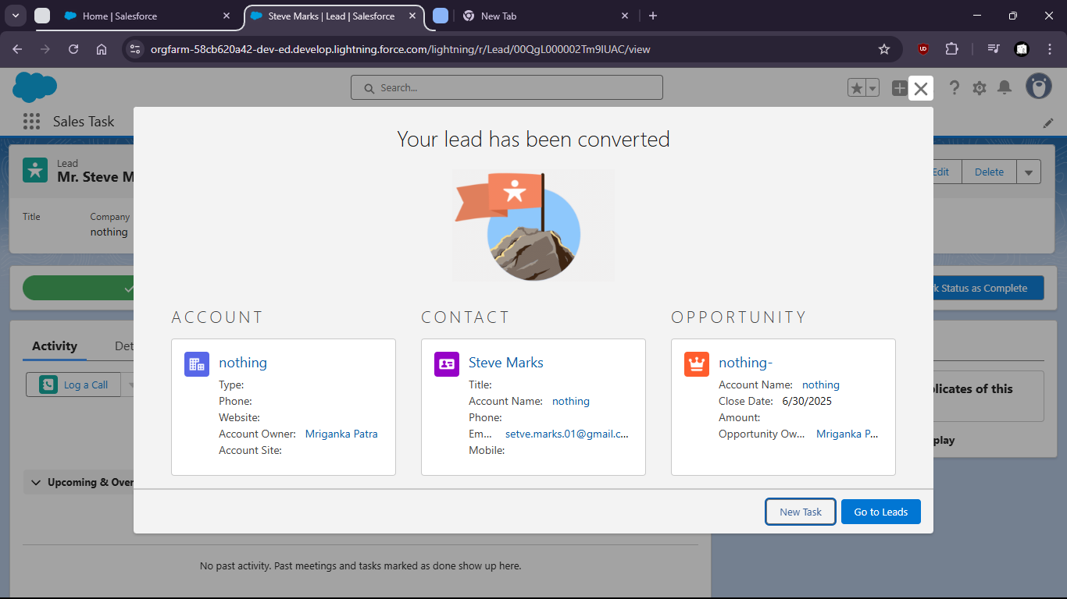

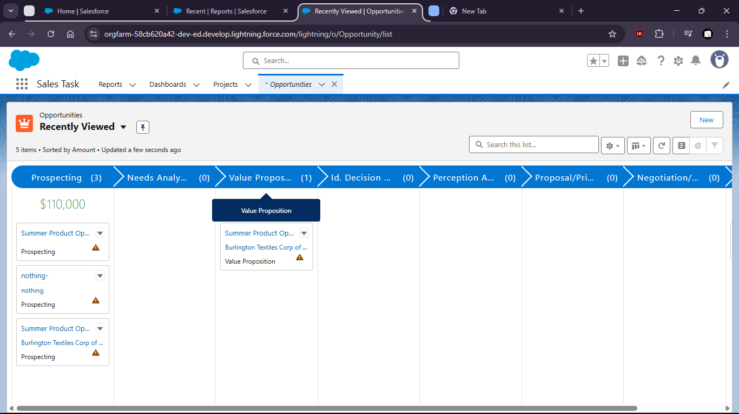

Task 5:Use Activity Timeline to log a call , schedule a task, and send an email from the Opportunity record

